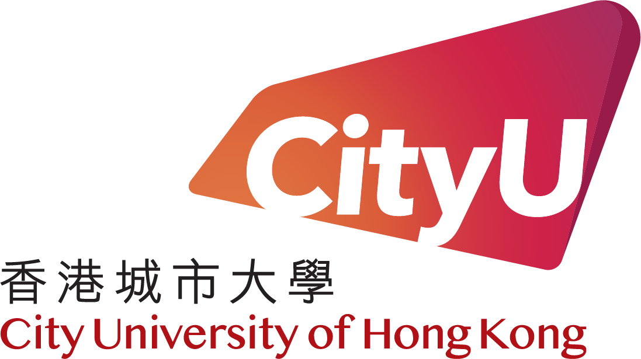
Application Form
職位申請表 Reference Number:

Notes for Applicants
- This application form should be completed in block letters and submitted via e-mail at hrojob@cityu.edu.hk or by post to the Human Resources Office, City University of Hong Kong, Tat Chee Avenue, Kowloon Tong, Hong Kong. Please use a separate sheet for further details and explanations where necessary.
- Please ensure that all parts in the form are completed accurately.
- Do not send any copies of academic certificates/qualifications. Successful applicants will be required to produce originals for photocopying/verification by the University in due course.
- All information provided will be treated in STRICT CONFIDENCE and used for appointment and other employment-related purposes by the University. It may be disclosed to personnel, departments or agencies authorised to process the information for purposes relating to appointment. Information of unsuccessful applicants will be destroyed one year after the recruitment exercise.
- Your application will not be considered if you fail to provide all information as requested.
- For correction of or access to personal data after submission of this application, please address your request to Data Protection Officer at data.protection@cityu.edu.hk.
- In the event of any inconsistency between the English version and the translated version of this Form, the English version shall prevail.
申請者需知
- 請將填妥的申請表格，透過電郵郵寄到hrojob@cityu.edu.hk或郵寄九龍塘達之路香港城市大學人力資源處收。如空位不敷填寫時，可另行寫在白紙上，連同表格一併交回。
- 請確實本表格所填寫資料正確無訛。
- 請勿郵寄學歷證書副本。大學將於選聘期間要求成功的申請者出示學歷證書正本以供複印核對。
- 所提供的資料將絕對保密，並將用作大學聘選及其他與僱傭有關事宜。所提供資料或會發放給處理聘選事宜之職員、部門或大學特許之代理人。未被取錄的申請者資料將於聘選過程完結一年後被銷毀。
- 如未能提供所需資料，申請者所申請之職位將不獲考慮。
- 申請者如欲更改或查閱填報在申請表格上的個人資料，請透過電郵data.protection@cityu.edu.hk向資料保護主任提出要求。
- 本表格的英文版本與翻譯版本之間若有任何不符之處，應以英文版本為準。

I. Job Information 職位資料
Job Reference Number  職位編號 |  |  | How did you learn of this vacancy  你從甚麼途徑知悉此空缺
Position Applied for  申請職位 |  |  | Department  部門

II. Personal Particulars 個人資料
Name in Chinese  中文姓名 |  |  |  | Name in English  英文姓名
Date of Birth (dd/mm/yyyy)  出生日期 (日/月/年) |  |  |  | Title  稱號 | Mr.  先生 |  | Mrs.  太太 | Ms.  女士 | Miss  小姐
Passport Number or  H.K. Identity Card Number  護照號碼或香港身份證號碼 |  |  |  | Phone Numbers 電話號碼 |  | Home 住所 :  Office 辦公室 :  Mobile 手提 :
Email Address
電郵地址
Correspondence Address
通訊地址
Residential Address (if different from the above address)
住址(如與上址不同)

Please put “x” in the box  whichever is applicable. 請在適當空格內劃上”x” (February 2025)

III. Education Background 學歷背景
Highest Education Level
最高學歷
Institution  機構 |  |  | Year of Award (yyyy)  頒發年份 (年)

IV. Education History (in reverse chronological order) 學歷 (請倒序列出)
Period  受學期 |  |  | From (mm/yyyy)  由 (月/年) |  | To (mm/yyyy)  至 (月/年)
School/College/University Attended
就讀學校名稱
Degree/Level Achieved  所獲資格 |  |  |  | Major  主修
Full-time or Part-time  全日制或部份時間就讀 |  |  |  | Date of Award (mm/yyyy)  頒發日期 (月/年)
Period  受學期 |  |  | From (mm/yyyy)  由 (月/年) |  | To (mm/yyyy)  至 (月/年)
School/College/University Attended
就讀學校名稱
Degree/Level Achieved  所獲資格 |  |  |  | Major  主修
Full-time or Part-time  全日制或部份時間就讀 |  |  |  | Date of Award (mm/yyyy)  頒發日期 (月/年)
Period  受學期 |  |  | From (mm/yyyy)  由 (月/年) |  | To (mm/yyyy)  至 (月/年)
School/College/University Attended
就讀學校名稱
Degree/Level Achieved  所獲資格 |  |  |  | Major  主修
Full-time or Part-time  全日制或部份時間就讀 |  |  |  | Date of Award (mm/yyyy)  頒發日期 (月/年)

V. Public Examination Results 公開考試成績
Date of Award (mm/yyyy)  頒發日期 (月/年) | Public Examination  公開考試 | Subject & Grade  科目及成績等級

VI. Technical or Occupational Training (in reverse chronological order) 職業或專門技能訓練 (請倒序列出)
Title and Description of Course/Training  訓練/課程名稱及性質 |  |  | Date of Award (mm/yyyy)  頒發日期 (月/年)
Name of Training Organization
受訓機構名稱
Period  受訓期 |  | From (mm/yyyy)  由 (月/年) |  | To (mm/yyyy)  至 (月/年)
Title and Description of Course/Training  訓練/課程名稱及性質 |  |  | Date of Award (mm/yyyy)  頒發日期 (月/年)
Name of Training Organization
受訓機構名稱
Period  受訓期 |  | From (mm/yyyy)  由 (月/年) |  | To (mm/yyyy)  至 (月/年)

VII. Other Relevant Skills/Pertinent Information (in reverse chronological order) 其他有關工作技能及相關資料 (請倒序列出)
Title and Description of License/ Certificate/Activity  牌照/證書/活動名稱及性質 |  |  | Date of Award (mm/yyyy)  頒發日期 (月/年)
Name of Organization
機構名稱
Period  時期 |  | From (mm/yyyy)  由 (月/年) |  | To (mm/yyyy)  至 (月/年)
Title and Description of License/ Certificate/Activity  牌照/證書/活動名稱及性質 |  |  | Date of Award (mm/yyyy)  頒發日期 (月/年)
Name of Organization
機構名稱
Period  時期 |  | From (mm/yyyy)  由 (月/年) |  | To (mm/yyyy)  至 (月/年)

VIII. Employment Record (in reverse chronological order) 工作經驗 (請倒序列出)
Employment Period  聘用期 |  |  | From (mm/yyyy)  由 (月/年) |  |  |  | To (mm/yyyy)  至 (月/年)
Title of Position Held  職位 |  |  |  |  |  | Full-time or Part-time  全職或兼職
Name of Employer and Address
工作機構名稱及地址
Nature of Duties
工作性質
Employment Period  聘用期 |  |  | From (mm/yyyy)  由 (月/年) |  |  |  | To (mm/yyyy)  至 (月/年)
Title of Position Held  職位 |  |  |  |  |  | Full-time or Part-time  全職或兼職
Name of Employer and Address
工作機構名稱及地址
Nature of Duties
工作性質
Employment Period  聘用期 |  |  | From (mm/yyyy)  由 (月/年) |  |  |  | To (mm/yyyy)  至 (月/年)
Title of Position Held  職位 |  |  |  |  |  | Full-time or Part-time  全職或兼職
Name of Employer and Address
工作機構名稱及地址
Nature of Duties
工作性質
Total Full-time Employment Period
總全職工作經驗 |  |  |  | years (年) months (月)

IX. Details of Present/Most Recent Employment Package 現職或最近就業的薪酬待遇
Basic Salary per month  每月底薪 |  |  |  | Incremental Date (dd/mm/yyyy) (if applicable)  加薪日期 (日/月/年) (如適用)
Gratuity  酬金 |  |  |  | Other Allowance (please specify)  其他津貼 (請詳細列明)
Earliest date available if appointed  如被錄用可於何日上任 |  |  |  | Expected Salary  要求薪金

X. Other Information 其他資料
Are you closely related to any employee of CityUHK (e.g. relative, close friend, former colleague, etc.)? Yes 是 No 否
你是否與任何現職於香港城巿大學之僱員有緊密關係 (例如﹕親屬、好朋友、前工作同事等)？
If yes, please state their names, positions and relationships to you:
如與大學僱員有緊密關係，請列明其姓名、職位名稱、部門及與申請者之關係﹕
Name  姓名 | Title of Position Held  職位名稱 |  |  | Department  部門 |  | Relationship  與申請者關係
Have you previously employed at CityUHK?  你曾否受聘於香港城巿大學？ |  | Yes 是 |  |  | No 否
 |  | please provide your CityUHK staff number請提供你的香港城巿大學僱員號碼
`
XI. Referee 諮詢人
Please provide information of the referee. The referee must be your present or the most recent employer who is able to comment on your suitability for appointment.
請提供諮詢人資料。 諮詢人須為現職或近期僱主，並可提供意見你是否適合此職位。
Name
姓名
Title of Position Held  職位 |  |  |  |  | Relationship  與申請者關係
Telephone Number  電話號碼 |  |  |  |  | Email Address  電郵地址
Name and Address of Organization
機構名稱及地址
City University of Hong Kong may write to your present and previous employers if you are invited for interview. If you wish us to give you prior notification before approaching your present employer, please put “ x ” in the box □. To facilitate the University to obtain the reference reports, where deemed necessary, please complete the authorization below:
如香港城巿大學邀請閣下出席面試，大學或會通知你現職及過往僱主。如希望大學預先通知你才與你的現職僱主聯絡，請在空格 □ 內畫上 “ x ”。為方便大學能取得諮詢報告，請填妥以下的授權書﹕
I hereby authorize City University of Hong Kong to obtain information relating to my work performance and employment record from my present and previous employers.
本人授權香港城巿大學可向本人的現職及過往僱主索取有關本人的工作表現及僱傭任職紀錄。
Date 日期﹕ |  |  |  |  |  |  | Signature 簽署 ﹕
Passport Number 護照號碼 or  H.K. Identity Card Number 香港身份證號碼﹕ |  |  |  |  |  |  | Name 姓名﹕

XII. Data Collection in Other Position(s) 資料收集用作其他空缺考慮
Are you willing to share your application information to other CityUHK openings? Yes 是 No 否
你是否願意讓大學轉介你的申請資料予其他的大學空缺？

XIII. Declaration 聲明
I declare that the information given in my application and in this form is correct and complete to the best of my knowledge. I understand that if I knowingly give false information or withhold any material information, City University of Hong Kong has every right to rescind any verbal/written offer of appointment and I will be liable to dismissal if I am eventually appointed by City University of Hong Kong.
本人謹此聲明，在此申請及申請書上填報之資料全屬確實無訛。若本人故意提供虛假資料，或隱瞞任何重要資料，香港城巿大學可取消發出的口頭或書面聘約，或縱使已獲聘任仍可遭解僱。

I acknowledge that I have read and understood the Personal Information Collection Statement (PICS) in the Appendix and, where applicable, the European Union and the United Kingdom General Data Protection Regulation Privacy Notice at https://www.cityu.edu.hk/hro/job/GDPRPrivacyNotice.pdf, and agree to the treatment of my personal data in accordance with the
above-mentioned document(s). I understand and agree to the transfer of my personal data outside Hong Kong in accordance with the above-mentioned document(s). I acknowledge and agree that some jurisdiction(s) where my personal data may be transferred to may not have in place data protection laws which are substantially similar to, or serve the same purposes as, the applicable privacy laws of Hong Kong or European Union/the United Kingdom, if applicable. I agree that this means that my personal data may not be protected to the same or similar level as that in Hong Kong or European Union/the United Kingdom, if applicable.
本人確認已閱讀和知悉附錄(英文版本)之《收集個人資料聲明》及歐盟與英國《通用數據保障條例》的私隱通知 (https://www.cityu.edu.hk/hro/job/GDPRPrivacyNotice.pdf) (如適用)，並同意香港城市大學根據收集個人資料聲明使用本人的個人資料。本人知悉及同意就收集個人資料聲明轉讓本人的個人資料至香港境外。本人確認及同意本人資料所轉移到香港以外之地方，該處可能沒有與個人資料（私隱）條例大體上相似或達致與此條例的目的相同的目的之法律，亦即是說，本人的個人資料未必可以獲得與在香港及歐盟/英國(如適用)相同或類似程度的保障。

Date 日期﹕ |  |  |  | Signature 簽署 ﹕
Please put “x” in the box  whichever is applicable. 請在適當空格內劃上”x”

Appendix 附錄
(只提供英文版本)

City University of Hong Kong (the "University")
Personal Information Collection Statement ("PICS") – Job Applicants
- The personal data collected in this Application Form will be used by the University to assess your suitability for the position you have applied for within the University and to determine the remuneration and benefits package, if applicable. If you are successful in securing a job with the University, data collected during the recruitment process will be transferred and used for the purposes related to your employment with the University.

- The personal data collected may be transferred, within or outside Hong Kong, to the University's subsidiary and associate companies; or to any other third party, for the above mentioned purposes. Some jurisdiction(s) where your personal data may be transferred to may not have in place data protection laws which are substantially similar to, or serve the same purposes as, the applicable privacy laws of the jurisdiction which governs your employment with the University (in Hong Kong, it is the Personal Data (Privacy) Ordinance). That means your personal data may not be protected to the same or similar level as that in Hong Kong or the place where you work.

- Unless indicated otherwise all information in this Application Form is compulsory and is required for selection purposes. If such data is not provided, then this will affect the processing and outcome of your application.

- It is the University's policy to retain personal data of unsuccessful applicants for a period of one year after completion of the recruitment exercise. Thereafter, your application together with all materials you provide will be disposed of.

- Under the Personal Data (Privacy) Ordinance, you have a right to request access to, and to request correction of, your personal data. The University reserves the right to charge a reasonable fee for the processing of any data access request. Please address your request to Data Protection Officer at data.protection@cityu.edu.hk.

